**Test case scenario by typing three first characters of each word:**

1. **Results appear by typing first three characters of each word:**

Machine generated alternative text:
wat 
Watermelon 

1. **The result is incase sensitive**

Machine generated alternative text:
cheRRy 

1. The result shows only with exact match and length of data is available.

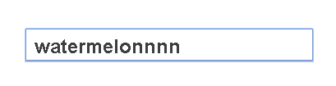

1. Using a test case dummy variable charSense in Javascript file we could check the accuracy of typed characters. In figure below with charSence = 1; available words narrow down each time upon typing matched characters “p” , “pe”, …:

Machine generated alternative text:
Papaya 
Pomegranate 

Machine generated alternative text:
Peach 
Pear 